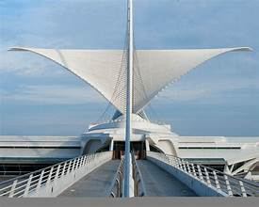
Architectural Gems of Milwaukee Tour $30
Date: Thursday, May 2, 2024
Time: Meet in the hotel lobby at 12:30; at 12:45, pick up your box lunch and board the bus; the bus will leave promptly at 1:00 p.m. The bus will return by 4:00 p.m.
Lunch will be a Jersey Mike’s box lunch of a mini sub, chips, and a cookie. Bottled water will be included. Register for the tour and indicate your meal choice and dietary needs on the registration form. Space is limited.
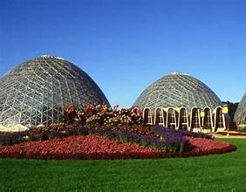
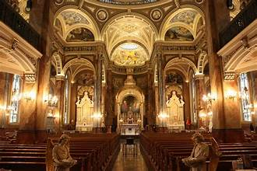
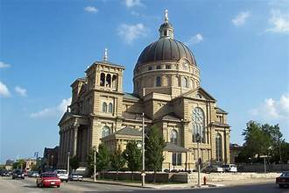
The tour will include a drive past American Family Field, home of the Milwaukee Brewers and a stop at the Mitchell Park Horticultural Conservatory (the Domes), where a self-guided tour will have you experience the heat of a desert oasis, the humidity of a tropical rain forest, and the bright colors of a floral garden. There will also be a docent guided tour of the Basilica of St. Josaphat. This little-known architectural gem which is on the National Register of Historic Places is a magnificent testimony to the strength of the Polish immigrants who resurrected it from the remains of the Chicago post office at the turn of the century. There will be time to visit the historical exhibit in the lower level. The bus will also drive by the magnificent brise soleil of the Milwaukee Art Museum designed by world renowned architect, Santiago Calatrava, as well as other architectural gems along the scenic Milwaukee lakefront. Dress is GFWC casual; show the logo! The bus will return in time for you to prepare for dinner on Thursday evening at the hotel. Ent
Cost of the bus courtesy of GFWC-WI Lakeshore District and GFWC-WI.

